**Interconnecting a Company’s Headquarters and Branches Using Default Routes and Floating Routes**

Student Version



Huawei Technologies Co., Ltd.

|  |
| --- |
| **Copyright © Huawei Technologies Co., Ltd. 2020. All rights reserved.**  No part of this document may be reproduced or transmitted in any form or by any means without prior written consent of Huawei Technologies Co., Ltd.  **Trademarks and Permissions**  HW_POS_RBG_Vertical-150ppi.png and other Huawei trademarks are trademarks of Huawei Technologies Co., Ltd.  All other trademarks and trade names mentioned in this document are the property of their respective holders.  **Notice**  The purchased products, services and features are stipulated by the contract made between Huawei and the customer. All or part of the products, services and features described in this document may not be within the purchase scope or the usage scope. Unless otherwise specified in the contract, all statements, information, and recommendations in this document are provided "AS IS" without warranties, guarantees or representations of any kind, either express or implied.  The information in this document is subject to change without notice. Every effort has been made in the preparation of this document to ensure accuracy of the contents, but all statements, information, and recommendations in this document do not constitute a warranty of any kind, express or implied. |

|  |  |
| --- | --- |
| Huawei Technologies Co., Ltd. | |
| Address: | Huawei Industrial Base  Bantian, Longgang  Shenzhen 518129  People's Republic of China |
| Website: | <https://e.huawei.com/> |

**Huawei Certification System**

Huawei Certification follows the "platform + ecosystem" development strategy, which is a new collaborative architecture of ICT infrastructure based on "Cloud-Pipe-Terminal". Huawei has set up a complete certification system consisting of three categories: ICT infrastructure certification, platform and service certification, and ICT vertical certification. It is the only certification system that covers all ICT technical fields in the industry. Huawei offers three levels of certification: Huawei Certified ICT Associate (HCIA), Huawei Certified ICT Professional (HCIP), and Huawei Certified ICT Expert (HCIE). Huawei Certification covers all ICT fields and adapts to the industry trend of ICT convergence. With its leading talent development system and certification standards, it is committed to fostering new ICT talent in the digital era, and building a sound ICT talent ecosystem.

Huawei Certified ICT Associate-Datacom (HCIA-Datacom) is designed for Huawei's frontline engineers and anyone who want to understand Huawei's datacom products and technologies. The HCIA-Datacom certification covers routing and switching principles, basic WLAN principles, network security basics, network management and O&M basics, SDN and programmability and automation basics.

The Huawei certification system introduces the industry, fosters innovation, and imparts cutting-edge datacom knowledge.

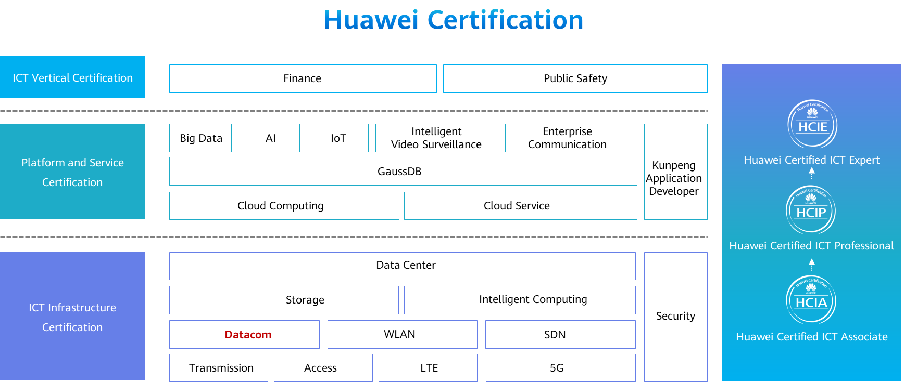

# Interconnecting a Company’s Headquarters and Branches Using Default Routes and Floating Routes

## Background

The company Jan16 has two offices: Beijing headquarters and Shanghai branch. The two offices are interconnected through routers R1 and R2, as shown in Figure 1-1. The two routers need to be configured with default routes and floating routes to improve link availability and enable access between PCs in the headquarters and branch. Figure 1-1 shows the network topology. The specific requirements are as follows:

Routers are connected through VPN lines. The headquarters typically connects to the branch using the primary link.

A floating route needs to be configured so that the backup link can be used for interconnection between the headquarters and branch when the primary link is disconnected.

The IP addresses and interfaces of the PCs and routers are shown in the following topology.

## Objectives

Upon completion of this task, you will be able to:

Learn how to configure static routes

Learn how to configure floating routes

## Topology

Lab Topology

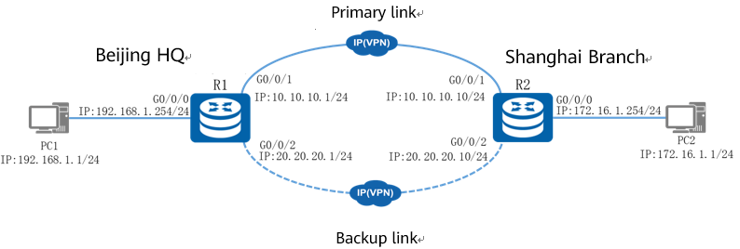

Beijing headquarters uses network segment 192.168.1.0, and Shanghai branch uses network segment 172.16.1.0. Both network segments use 24-bit subnet masks. Default routes and floating routes need to be configured on the routers. During the preference configuration of a floating route, network segment 10.10.10.0 is configured as the primary link and network segment 20.20.20.0 as the backup link. In this way, PCs in the headquarters and branch can communicate with each other.

The IP address planning and interface planning can be referred in the appendix.

## Implementation

### Roadmap

1. Configure interfaces on each router and PC.
2. Configure static routes on R1 and R2.
3. Configure floating routes on R1 and R2.

### Procedure

Configure interfaces on R1 and R2.

#Configure R1.

#Configure R2.

Configure static routes on R1 and R2.

#Configure R1.

#Configure R2.

Configure floating routes on R1 and R2.

#Configure R1.

#Configure R2.

Configure IP addresses for PCs.

Configure the IP addresses of PCs referred by the appendix.

* 1. **Verification**

Check the routing table.

#R1 routing table

[R1]display ip routing-table

Route Flags: R - relay, D - download to fib

------------------------------------------------------------------------------

Routing Tables: Public

Destinations : 14 Routes : 14

Destination/Mask Proto Pre Cost Flags NextHop Interface

0.0.0.0/0 Static 60 0 RD 10.10.10.10 GigabitEthernet0/0/1

10.10.10.0/24 Direct 0 0 D 10.10.10.1 GigabitEthernet0/0/1

10.10.10.1/32 Direct 0 0 D 127.0.0.1 GigabitEthernet0/0/1

10.10.10.255/32 Direct 0 0 D 127.0.0.1 GigabitEthernet0/0/1

20.20.20.0/24 Direct 0 0 D 20.20.20.1 GigabitEthernet0/0/2

20.20.20.1/32 Direct 0 0 D 127.0.0.1 GigabitEthernet0/0/2

20.20.20.255/32 Direct 0 0 D 127.0.0.1 GigabitEthernet0/0/2

127.0.0.0/8 Direct 0 0 D 127.0.0.1 InLoopBack0

127.0.0.1/32 Direct 0 0 D 127.0.0.1 InLoopBack0

127.255.255.255/32 Direct 0 0 D 127.0.0.1 InLoopBack0

192.168.1.0/24 Direct 0 0 D 192.168.1.254 GigabitEthernet0/0/0

192.168.1.254/32 Direct 0 0 D 127.0.0.1 GigabitEthernet0/0/0

192.168.1.255/32 Direct 0 0 D 127.0.0.1 GigabitEthernet0/0/0

255.255.255.255/32 Direct 0 0 D 127.0.0.1 InLoopBack0

#R2 routing table

[R2]display ip routing-table

Route Flags: R - relay, D - download to fib

------------------------------------------------------------------------------

Routing Tables: Public

Destinations : 14 Routes : 14

Destination/Mask Proto Pre Cost Flags NextHop Interface

0.0.0.0/0 Static 60 0 RD 10.10.10.1 GigabitEthernet0/0/1

10.10.10.0/24 Direct 0 0 D 10.10.10.10 GigabitEthernet0/0/1

10.10.10.10/32 Direct 0 0 D 127.0.0.1 GigabitEthernet0/0/1

10.10.10.255/32 Direct 0 0 D 127.0.0.1 GigabitEthernet0/0/1

20.20.20.0/24 Direct 0 0 D 20.20.20.10 GigabitEthernet0/0/2

20.20.20.10/32 Direct 0 0 D 127.0.0.1 GigabitEthernet0/0/2

20.20.20.255/32 Direct 0 0 D 127.0.0.1 GigabitEthernet0/0/2

127.0.0.0/8 Direct 0 0 D 127.0.0.1 InLoopBack0

127.0.0.1/32 Direct 0 0 D 127.0.0.1 InLoopBack0

127.255.255.255/32 Direct 0 0 D 127.0.0.1 InLoopBack0

172.16.1.0/24 Direct 0 0 D 172.16.1.254 GigabitEthernet0/0/0

172.16.1.254/32 Direct 0 0 D 127.0.0.1 GigabitEthernet0/0/0

172.16.1.255/32 Direct 0 0 D 127.0.0.1 GigabitEthernet0/0/0

255.255.255.255/32 Direct 0 0 D 127.0.0.1 InLoopBack0

Test the interoperability of PCs.

Run the ping command to test communication between PC1 and PC2.

Ping PC2 from PC1.

[C:\~]$ ping 172.16.1.1

Ping 172.16.1.1: 32 data bytes, Press Ctrl\_C to break

From 172.16.1.1: bytes=32 seq=1 ttl=126 time=31 ms

From 172.16.1.1: bytes=32 seq=2 ttl=126 time=31 ms

From 172.16.1.1: bytes=32 seq=3 ttl=126 time=31 ms

From 172.16.1.1: bytes=32 seq=4 ttl=126 time=47 ms

From 172.16.1.1: bytes=32 seq=5 ttl=126 time=47 ms

--- 172.16.1.1 ping statistics ---

5 packet(s) transmitted

5 packet(s) received

0.00% packet loss

round-trip min/avg/max = 31/37/47 ms

The preceding command output shows that PC1 and PC2 communicate with each other properly. Then run the tracert command on PC1 to check the gateway through which packets sent from PC1 to PC2 pass.

[C:\~]$ tracert 172.16.1.1

traceroute to 172.16.1.1, 8 hops max

(ICMP), press Ctrl+C to stop

1 192.168.1.254 <1 ms 16 ms 15 ms

2 10.10.10.10 32 ms 46 ms 47 ms

3 172.16.1.1 47 ms 31 ms 47 ms

The preceding command output shows that PCs communicate with each other through the primary link.

Test communication between PCs through the backup link.

Shut down interfaces at both ends of the primary link and run the ping command to test communication between PC1 and PC2.

Ping PC2 from PC1.

[C:\~]$ping 172.16.1.1

Ping 172.16.1.1: 32 data bytes, Press Ctrl\_C to break

From 172.16.1.1: bytes=32 seq=1 ttl=126 time=46 ms

From 172.16.1.1: bytes=32 seq=2 ttl=126 time=47 ms

From 172.16.1.1: bytes=32 seq=3 ttl=126 time=47 ms

From 172.16.1.1: bytes=32 seq=4 ttl=126 time=47 ms

From 172.16.1.1: bytes=32 seq=5 ttl=126 time=47 ms

--- 172.16.1.1 ping statistics ---

5 packet(s) transmitted

5 packet(s) received

0.00% packet loss

round-trip min/avg/max = 46/46/47 ms

The preceding command output shows that PC1 and PC2 communicate with each other properly. Then run the tracert command on PC1 to check the gateway through which packets sent from PC1 to PC2 pass.

[C:\~]$tracert 172.16.1.1

traceroute to 172.16.1.1, 8 hops max

(ICMP), press Ctrl+C to stop

1 192.168.1.254 <1 ms 15 ms 16 ms

2 20.20.20.10 31 ms 47 ms 47 ms

3 172.16.1.1 47 ms 31 ms 47 ms

The preceding command output shows that PCs communicate with each other through the backup link.

**----End**

## Appendix

IP address planning

| Device | Interface | IP Address |
| --- | --- | --- |
| R1 | G0/0/0 | 192.168.1.254/24 |
| R1 | G0/0/1 | 10.10.10.1/24 |
| R1 | G0/0/2 | 20.20.20.1/24 |
| R2 | G0/0/0 | 172.16.1.254/24 |
| R2 | G0/0/1 | 10.10.10.10/24 |
| R2 | G0/0/2 | 20.20.20.10/24 |
| PC1 | Eth0/0/1 | 192.168.1.1/24 |
| PC2 | Eth0/0/1 | 172.16.1.1/24 |

Interface planning

| Local Device | Local Interface | Peer Device | Peer Interface |
| --- | --- | --- | --- |
| R1 | G0/0/0 | PC1 | Eth0/0/1 |
| R1 | G0/0/1 | R2 | G0/0/1 |
| R1 | G0/0/2 | R2 | G0/0/2 |
| R2 | G0/0/0 | PC2 | Eth0/0/1 |
| R2 | G0/0/1 | R1 | G0/0/1 |
| R2 | G0/0/2 | R1 | G0/0/2 |
| PC1 | Eth0/0/1 | R1 | G0/0/0 |
| PC2 | Eth0/0/1 | R2 | G0/0/0 |